**ANSWERS**

JBSC

Year 12 ATAR Psychology

Assessment Task 5 – Test 2

56 marks (5% Response)

**UNIT LEARNING CONTEXT:**

*Diversity and the Community*

**OUTCOMES:**

|  |  |
| --- | --- |
| *Outcome 1:* | *Psychological understandings* |
| *Outcome 3:* | *Applying and relating psychological understandings* |
| *Outcome 4:* | *Communication in psychology* |

**ALLOCATED TIME FOR THE TASK:**

* *You will have one period to complete the test in class*.

**INSTRUCTIONS:**

* *Attempt all questions*
* *No notes, files etc. to be accessed during the test*

|  |  |
| --- | --- |
| **Section One – Multiple Choice** | |
| **Total** | **/ 17** |

|  |  |
| --- | --- |
| **Section Two – Short Answer** | |
| Question 1 – Cognition | / 30 |
| Question 2 – Communication | / 12 |
| **Total** | **/ 42** |

|  |  |
| --- | --- |
| **Total Marks** | |
| Section 1 – Multiple Choice | / 17 |
| Section 2 – Short Answer | / 42 |
| **Assessment Task 5 – Total Marks** | **/ 62** |

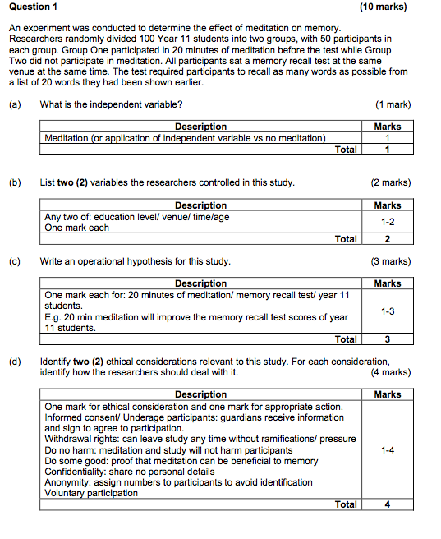

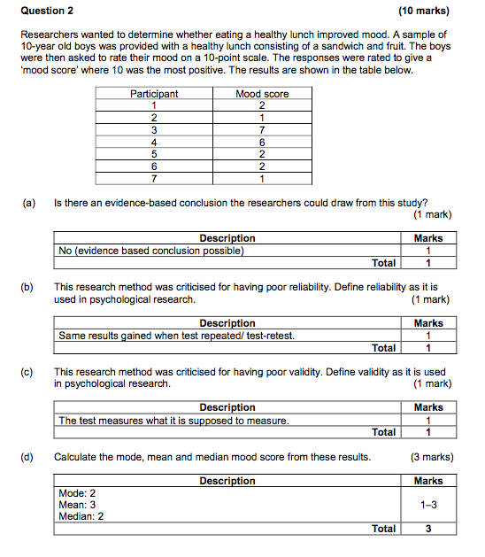

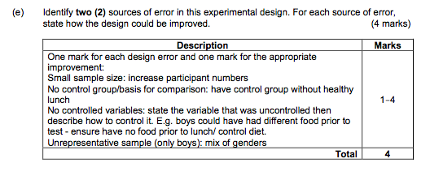

Section Two - Short answer questions

2 questions = 42 marks

**Question One – Cognition (30 marks)**

1. Explain how information travels between the brain’s memory stores according to the *multi-store model of memory*. Include all relevant terminology in your response. (*10 marks*)

**Sensory memory (iconic memory and echoic memory); attention; short-term memory/ working memory; forgetting; encoding; storage; long-term memory; retrieval; rehearsal (maintenance and elaborative)**

1. Define the following terms: (*4 marks*)
   1. *Reinforcement*: ***a consequence that causes a behaviour to occur more***

***frequently.***

* 1. *Punishment*: ***a consequence that causes a behaviour to occur less***

***frequently.***

1. Describe an example of: (*4 marks*)
   1. *Negative reinforcement*: ***Individual student response. An example could be a child***

***does really well in a test so their parents say they do not have to do their chores for the week***

* 1. *Positive punishment*: ***Individual student response. An example could be a child***

***does poorly in a test due to lack of study so their parents say have to do extra study for the next two weeks***

* 1. Outline how *cognitive behaviour therapy* (CBT) could be used to treat this person’s phobia.

(*6 marks*)

**thoughts effect behaviour**

**identify unhelpful thoughts & replace with positive associations (2)**

**New associations result in modified emotions and behaviour**

**Provide example (2)**

**Question Two – Communication (12 marks)**

*“Women create feelings of closeness by conversing with their friends and lovers. Men don’t use communication in this way, so they can’t figure out why their women are continually talk, talk, talking. Eventually, many men just tune their women out”*

- Laura Morrison commenting on Deborah Tannen’s book *You Just Don’t Understand*

Explain how men and women use communication for different purposes. Include in your answer how this can lead to misunderstanding and even conflict in a relationship. (*8 marks*)

**Report (1) explanation (up to 2 marks)**

**Rapport (1) explanation(up to 2 marks)**

**How it creates conflict (2) e.g. women talk about a problem as wish for their emotions to be validated while men just want to provide a solution.**

1. Explain how the *nature of the communication* and the *characteristics of the audience* make the above advertisement potentially highly persuasive. (*4 marks*)
   1. *Nature of the communication*:

**Fear/ emotional response technique and explain**

* 1. *Characteristics of the audience*:

**Clearly targeted at young males entering a trade/workforce – employs a simple, commonly thought quote and the man in the image is representation of the demographic being targeted.**

